Hardware DOC112

FUNCTIONS

Digits | C1 | C2 | Output
D3 = 1 | 0 | 0 | A⊕B
D2 = 1 | 0 | 2 | A’
D1 = 2 | 1 | 0 | A’•B’
D0 = 3 | 1 | 1 | A’+B’

TRUTH TABLE

C1 | C2 | A | B | R | Function
0  0  0  0 | 0  0  0  0 | 0  0  1  1 | 1  0  1  0 | 1  0  0  1 | A⊕B
0  0  0  0 | 1  1  1  1 | 0  0  1  1 | 1  0  1  0 | 1  1  0  0 | A’
1  1  1  1 | 0  0  0  0 | 0  0  1  1 | 1  0  1  0 | 0  1  0  0 | A’•B’
1  1  1  1 | 1  1  1  1 | 0  0  1  1 | 1  0  1  0 | 1  1  0  1 | A’+B’

KARNAUGH MAP

A,B
 | 00 | 01 | 11 | 10
00 | 0 | 1 | 0 | 1
01  C1,C2 | 1 | 1 | 0 | 0
11 | 1 | 1 | 0 | 1
10 | 1 | 0 | 0 | 0

MINIMIZED EXPRESSION

R = A’• C2 + A’•B’•C1 + A’•B• C1’ + B’•C1•C2 + B’•C1’•C2’•A

R = A’•(C2 + B’•C1 + B•C1’) + B’• (C1•C2 + C1’•C2’•A)

The circuit resulting from this minimized expression is:

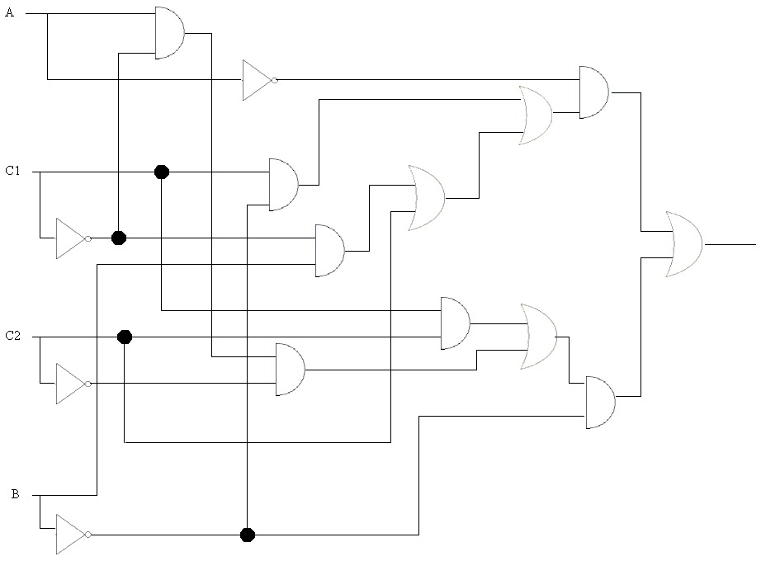

Using only inverters and 2-input NAND and AND gates:

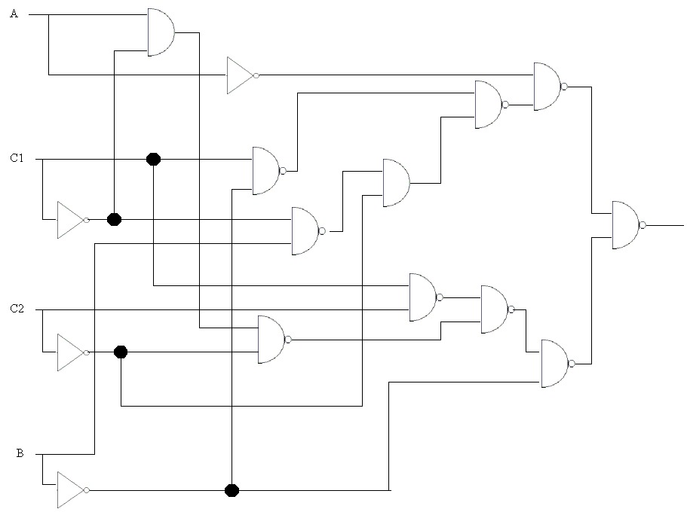

The cost of this circuit can be calculated:

IC type | U | Cost
SN7400 | 1 | 0.98
SN7400 | 1 | 0.98
SN7400 | ¼ | 0.62
SN7406 | 4/6 | 0.82
SN7408 | ¼ | 0.62

The total cost is £3.92

However, the 9th and final NAND can made by placing an inverter after an AND gate (from the spare pins on the SN7408 and SN7406 respectively). This reduces the cost as there is now only need for 4 IC’s:

IC type | U | Cost
SN7400 | 1 | 0.98
SN7400 | 1 | 0.98
SN7406 | 5/6 | 0.90
SN7408 | 2/4 | 0.74

The total cost in now £3.60

THIS IS THE CIRCUIT THAT WILL BE BUILT

(An alternative way of reducing the number of IC’s is to make the AND gate from a NAND gate and an inverter, thus eliminating the need for a SN7408 altogether:

IC type | U | Cost
SN7400 | 1 | 0.98
SN7400 | 1 | 0.98
SN7400 | 2/4 | 0.74
SN7406 | 5/6 | 0.90

The cost is again £3.60)

The final circuit

Here is the final design complete with IC and pin numbers:

